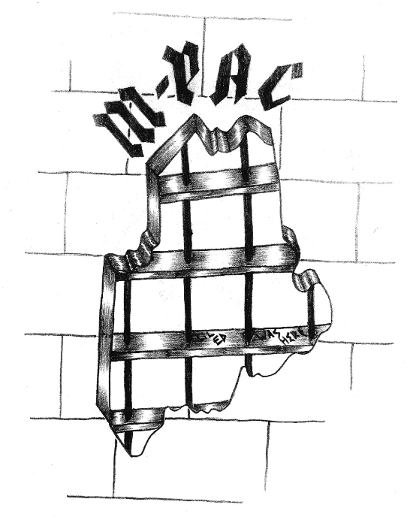
Maine Prisoner Advocacy Coalition (MPAC)
maineprisoneradvocacy.org
______________________
PO Box 873 . Ellsworth ME 04614
207-374-3608

June 15, 2012

Testimony presented to:
Senator Dick Durbin and Members of the Senate Judiciary Subcommittee on the Constitution, Civil Rights, and Human Rights

From: James Bergin of Blue Hill, Maine, Co-Coordinator,
Maine Prisoner Advocacy Coalition (M-PAC)

As Co-Coordinator of Maine Prisoner Advocacy Coalition (M-PAC, www.maineprisoneradvocacy.org) in the state of Maine, I am pleased to testify on the experience of M-PAC in helping move the Maine Department of Corrections (MDOC / DOC) to adopt a Policy restricting the use (and abuse) of solitary confinement (Special Management Unit) as a means of punishment and control. Thank you for accepting this testimony on this most important occasion.

In working as a volunteer Prisoner Advocate with my wife and colleague Judith Garvey, for the last twelve years, at the county level (Volunteers for Hancock County Jail Residents www.jailvolunteers.org), we had become increasing alarmed about the long term deleterious effects, in terms of psychological trauma and recidivism, as a direct consequence of severe sensory deprivation from being placed in solitary confinement.

We don't need to list here the types of destructive behaviors that are manifested as a result, but only to say that the use of solitary confinement actually creates, and stimulates, the dysfunctional behaviors it is supposed to "correct." In addition, despite its failure to alter behavior in a positive way, housing a prisoner in a solitary confinement unit doubles or triples the costs to the taxpayers. And what we get for our money is what Senator John McCain described as the worst form of torture he experienced as a POW in North Vietnam.

As this Committee is aware, the use of solitary confinement is going on all across the United States, where it has nothing to do with rehabilitation: rather it causes anti-social behavior that, as we have seen, manifests itself in prison and in the community upon a prisoner's release. Solitary confinement is now a structural part of almost all prisons, and the Policy du jour in dealing with aberrant behavior.

And so it was in Maine, under the previous MDOC administration of Commissioner Martin Magnusson, and a Board of Visitors, under the chairmanship of Jon Wilson, that adhered to the status quo, despite protestations on the part of Prisoner Advocates. With an entrenched bureaucracy, a Board of overseers unwilling to initiate change, and the lack of transparency overall, the only recourse left to Advocates, outside of ongoing protests, was to propose legislation at the State level that would seek to limit and control the use of solitary at MSP.

This process was begun in 2009 through a Maine State Representative, James Schatz (D), and composed of a committee of Advocates who were soon joined by the ACLU of Maine, NAACP-Portland, Solitary Watch, CURE, Maine Council of Churches, Immigrant Legal Advocacy Coalition, and numerous other organizations, forming the Coalition “Mainers against Solitary Confinement,” which later became Maine Prisoner Advocacy Coalition (M-PAC).

The resulting Bill – LD 1611 – was modest in that given the DOC's intransigence, Advocates were not optimistic in gaining a major transformation. It established necessary limits to the use of solitary based on the current research findings on this form of deprivation, presumably before the point where severe psychological damage can take place. Advocates also wanted to ensure that each prisoner in solitary would be checked at regular intervals for mental and physical deterioration by a trained mental health practitioner. We also hoped to enforce an end to “cell extractions,” “restraint chairs,” and other so-called “tools.” With this Bill, it seemed that we were not pushing the envelope too far, and that our legislation would be viewed as moderate and politically capable of passing through the state legislative process successfully, despite views to the contrary on the part of Maine’s DOC.

With the great resources of the ACLU of Maine, M-PAC mustered a large group of volunteers, organizations, and experts on sensory deprivation to testify on behalf of LD 1611 in front of the Criminal Justice and Public Safety Committee of the Maine State Legislature. At the same time the MDOC, under then-Commissioner Martin Magnusson, turned out a veritable army of staff correction officers, administrators, and the Chairman of the Board to Visitors, Jon Wilson, to testify on the use of Solitary Confinement as an important "tool" that was necessary for the security of the prisons and the community.

"Security," as used by the MDOC, is a term common throughout the entire criminal justice system used to justify many forms of behavior, or policy, whether abusive, inhumane, or not. As it pertains to Maine’s SMU, solitary was said to be for "the worst of the worst" from whom the rest of the Inmate population and staff needed protection. This is a common old saw which was repeated over and over at the LD 1611 Hearing as a way of perpetuating the stereotype of the out-of-control prisoners who need to be confined.

This argument gained some resonance with members of the Criminal Justice Committee who had backgrounds in law enforcement, while others on the Committee waffled from the somewhat intimidating display of uniformed force to the explanations of medical and psychological harm. The expert witnesses and legal testimony, as well as Clergy who testified in support of the legislation gave pause for thought on the part of the committee. As a result, the Legislation, after numerous rewrites, was sent to the floor of the Legislature for a vote, where the Bill LD 1611 sustained one of the longest floor debates in recent legislative memory.

Finally, when the vote was taken the Bill did not pass; however, all was not lost. In response to the testimony, and the near majority of Legislators in favor of prison reform, a Resolve to study the use of solitary confinement and recommend changes was agreed to by legislators. The Resolve, while not the passage of the Bill Advocates had fought for, was critically considered as a move in the correct direction, pending the findings and recommendations of the committee selected to undertake the study. (For info on the process and history of Maine LD 1611: http://www.maineprisoneradvocacy.org/solitaryconfinement.html)

After months of anticipation, the Report coming from the Resolve, authored by Dr. Steven Sherrets and others, was issued, and much to advocates’ surprise contained recommendations which, to a certain extent, reflected some of the reforms M-PAC advocated for, including a more humane and carefully monitored use of the SMU, citing in the Report the destructive effect of solitary confinement on Prisoners as the basis for these recommendations. The Resolve, subsequent Report, and the appointment of the new MDOC Commissioner, Joseph Ponte, created a "perfect storm" for reform of Maine’s prisons, of the SMU, the Mental Health Unit (MHU), and other units in the prisons, to be enacted through Policy changes, the underpinning of which was now viewed by the MDOC as rehabilitation instead of punishment.

To do this, Commissioner Ponte formed a Working Committee to revise existing Policy and to advise on training of Staff that would stress different, more efficient forms of grievance resolution between Staff and Inmates. The purpose of this training is to provide Staff with new "tools" as a means of control, as opposed to relying on the threat, and use, of an Inmate being thrown in the "hole" (solitary) for any transgression deemed unacceptable by Staff.

This Working Committee had weekly meetings through a year, meeting at Maine State Prison in Warren, Maine, and consisted of MDOC Administrative Staff, the Commissioner, Prison Warden Patricia Barnhart, Dr. Steven Sherrets, author of the Report, various prison Staff, Board of Visitors Chair Jon Wilson, and for the sake of transparency, two independent Advocates, Rachel Talbot-Ross, President of the Maine NAACP-Portland, and Jim Bergin, Co-Coordinator of the Maine Prisoner Advocacy Coalition (M-PAC). The presence of the two Advocates on the Committee, at the suggestion of Commissioner Ponte, was a radical innovation for the MDOC that was in marked contrast to the previous MDOC Administration for which "transparency" was a dirty word, and M-PAC was a problem that wouldn't go away.

The combination of Advocates and MDOC Administrators on the Committee made for an interesting dynamic for the former adversaries during the Legislative hearing for LD 1611, and on a multitude of actions by Advocates against MDOC for its overall treatment of Prisoners. The role of Advocates, as part of the Working Committee, evolved from quiet observation to a proactive role of representing Prisoners’ concerns and objecting to certain policies that hinted of the same old way of doing business. With Advocates’ presence at the table, a dialogue took place that energized the Committee’s work and resulted in creating a “sea change” at Maine State Prison and throughout Maine’s prison system that is still in process. Sitting at the table with MDOC was a constant balance for Advocates of continuing to speak strongly for change while not alienating those working for the MDOC. The concern was to avoid being “co-opted” by relationships formed with those who control the lives of Prisoners. This goal was successfully met.

As the meetings progressed, it became apparent that MDOC Administrators had suddenly, and seemingly miraculously, become transformed and were now speaking the language of reform under the guidance of the Committee Chair, Rod Bouffard, Director of Maine’s Long Creek Juvenile Center, which was now being used as a model of reform having successfully been in the vanguard of eliminating the use of solitary confinement for its Juvenile Inmates. The Advocates almost immediately found common ground with Mr. Bouffard and offered him support and suggestions for his proposed policy changes to the other MDOC administrators on the Committee.

The subtext to the SMU Policy changes is ideally based on the potential of all but eliminating the use of solitary, and charting a gradual means through Policy changes and data collection to get there. The data collection is used as a means to measure the success or failure of the Policy changes, and where necessary to "tweak" the changes to effect the desired results. This process is referred to by the MDOC as evidence-based change, and is now reviewed by ongoing quarterly meetings of the Working Committee, which to date has met three times.

The participation of Prisoner Advocates at these Policy Meetings, and in subsequent MDOC committees dealing with aspects of prison life, is a major transformation toward transparency in the MDOC and speaks well for Maine’s State Legislators taking the initiative of commissioning a Resolve to examine the Correctional system, and Commissioner Ponte, in response to this Report, having the experience and perspective to effect major changes in concert with Advocates. However, this is just a beginning, since longer range problems, some of which are beyond the range of Policy changes, still persist.

While Policy can be changed with the stroke of a pen, so to speak, the Staff on the floor with Prisoners, some of whom have been there for over thirty years, do not change so easily and are sometimes unwilling to leave their comfort zone in response to Policy. The culture of Prisons will take time to change, but it has to start somewhere, and to that end enlightened leadership, along with involved Prisoner Advocates and citizens, is a good start. M-PAC in its distinct role of Prisoner Advocacy continues to independently monitor the effects of these Policy changes on the day-to-day lives of Inmates in terms of their treatment by correctional staff, healthcare providers, rehabilitative programs, and ultimately whether, upon release, they are equipped to readjust as productive members of their communities.

In looking to the future, M-PAC, ACLU-Maine, and the NAACP will be meeting in June with The Sentencing Project, the Chief Justice of Maine, Chairs of the Criminal Justice and Public Safety Committee of the Maine Sate Legislature, Commissioner Joseph Ponte, and others to discuss initiating a review of Maine sentencing guidelines as a hopeful prelude to enacting sentence reform. As
M-PAC moves forward members are optimistic that the established collaboration in corrections reform between the MDOC and Prisoner Advocates will encourage an atmosphere for constructive change in the Criminal Justice System here in Maine and the rest of the country.

In sum, solitary confinement units throughout the USA must be closed as quickly as possible to protect the mental and physical health of prisoners, public safety in our communities, and financial security for states. Maine’s Prisoner Advocates stand ready to assist other Advocacy groups on advocacy procedures used in Maine to greatly limit use of the “Special Management Units” in Maine’s prisons.

Respectfully submitted,

James F. Bergin, Co-Coordinator
Maine Prisoner Advocacy Coalition (M-PAC)
www.maineprisoneradvocacy.org
207-374-3608

